- We've revised up our assumptions for oil and gas prices following further disruption to shipping through the Strait of Hormuz and significant damage to energy infrastructure across the Gulf region. We now expect UK CPI inflation to top 4% in H2 2026 before cooling in 2027. We've also cut our already-weak GDP forecasts for this year and next.
- The Bank of England's Monetary Policy Committee voted unanimously to keep Bank Rate at 3.75% at this week's meeting. The MPC opened the door to rate hikes if inflation expectations become de-anchored. But we think the most likely outcome is that the committee hold Bank Rate at its current restrictive level for the rest of this year and well into 2027.
It's been another week dominated by the war in the Middle East and turbulence in global commodity markets. Our Commodities Team now sees global oil and natural gas prices staying higher for longer, with the Strait of Hormuz likely to remain impassable until May.
Our updated UK forecast, which we plan to publish later today, assumes that the Brent crude oil price averages $113 a barrel in Q2, followed by slow normalisation. We also project a larger and more persistent rise in European gas prices.
As with our previous baseline and the two alternative scenarios we published last week, the main transmission channel to the economy is through higher inflation. Under our updated assumptions, we now anticipate a much sharper rise in petrol prices, while higher wholesale gas prices cause a 19% increase in the Ofgem energy price cap in July. We expect CPI inflation to peak at 4.1% in Q3 2026, and average 3.6% across this year as a whole – 1.3ppts higher than our pre-conflict baseline (Chart 1). But these increases should unwind over the course of 2027, with inflation forecast to drop below the Bank of England's 2% target in the second half of next year.
Chart 1: Higher oil and gas prices signal much stronger inflation and weaker activity growth
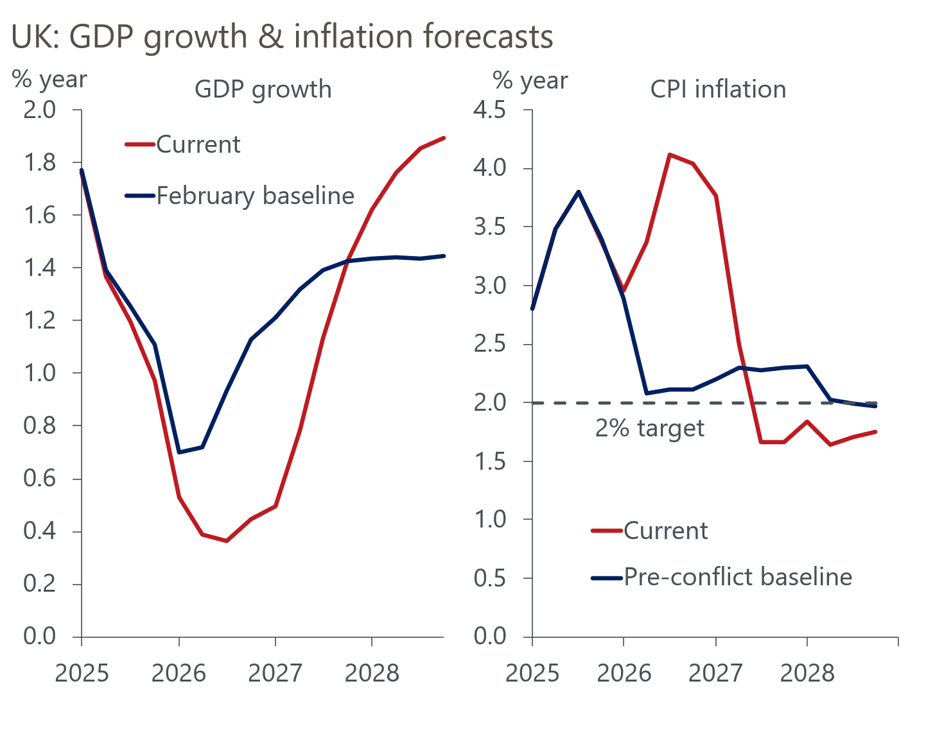
Sources: Oxford Economics, Haver Analytics

We expect a larger rise in inflation over the next year to result in a more pronounced slowdown in activity growth. Higher fuel and energy costs, as well as the upward pressure these will have on other prices, point to a greater squeeze on real household incomes. Corporate profitability, already at very low levels, will also be squeezed further, suggesting more downward pressure on capital spending. Therefore, we now project GDP growth of 0.4% this year and 1% next year, compared to our February baseline of 0.9% in 2026 and 1.3% in 2027 respectively.
Concerns that higher headline inflation could cause inflation expectations to become de-anchored have put the BoE's Monetary Policy Committee into a holding pattern, as it awaits more information about the nature of the energy shock. The minutes of this week's MPC meeting showed that the war in the Middle East has become the key issue for all committee members, who unanimously agreed it was too soon to draw firm conclusions on the appropriate policy response – a similar message to that delivered by the Federal Reserve and the European Central Bank this week.
Before the outbreak of the war, most of the committee had a bias to loosen policy further, due to the weak outlook for the economy and the fragile labour market. Neither of these worries have dissipated. So if the conflict proves short-lived and oil and gas prices drop back quickly, the dovish majority could return to their original position later this year.
However, we think oil and gas prices will remain higher for longer. And the experience of the 2022-2023 inflation episode means the committee is likely to remain wary of the risks of the initial energy price shock rippling through to consumers' and firms' price expectations, keeping inflation above-target for a prolonged period. Though the minutes made clear that the next move could either be a hike or a cut, financial markets interpreted the MPC's messaging very hawkishly, adding a full 25bp rate hike this year to market pricing. That brought total pricing for hikes to around 70bps for 2026 at the time of writing.
While we agree that a rate hike this year is certainly possible, depending on the duration of the war in the Middle East, it's not our central forecast. Indeed, in an interview with the BBC after the interest rate announcement, Governor Andrew Bailey suggested that markets were "getting ahead" of themselves in assuming multiple rate rises. Bailey's comments were clearly more dovish than the minutes, suggesting he felt the initial message had been misinterpreted.
The economy's starting position is very different to the 2022-2023 episode, a point which several MPC members emphasised in their individual paragraphs. There is far more slack in the economy, which limits firms' pricing power and workers' bargaining power in wage negotiations. The committee also feels that the current policy rate is already "somewhat restrictive", while there is much less scope for expansionary fiscal policy to support activity in the same way as it did at the time of the previous energy shock.
As a result, if our oil and gas price assumptions are in the right ballpark, we think the most likely outcome is that the MPC keeps Bank Rate at its current level for the rest of this year and well into 2027 (Chart 2).
Chart 2: We think the MPC will maintain current interest rates well into next year
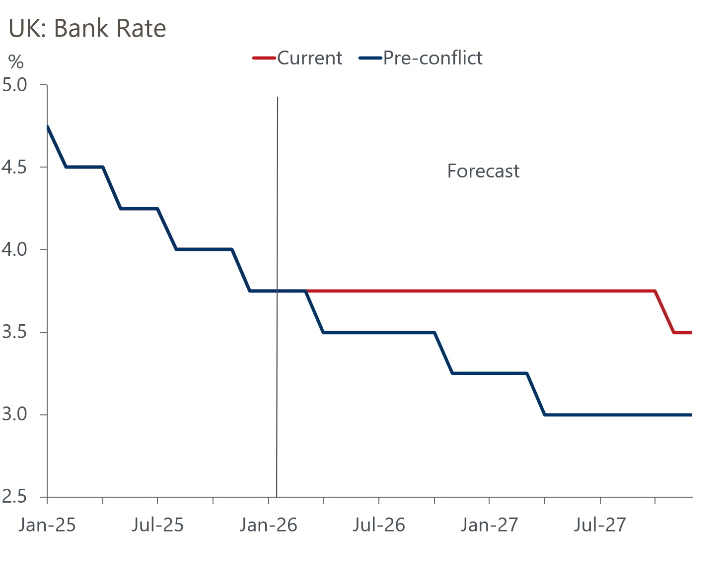
Sources: Oxford Economics, Haver Analytics

The week ahead
CPI inflation softened in January, and we expect the disinflationary trend to have continued in February. Weekly data from the Department for Energy Security and Net Zero suggests petrol prices fell by 1.1% between January and February, in contrast to a 1.5% increase between those months a year earlier. Meanwhile, we expect the contribution from the services category to have weakened slightly in February. Overall, we think CPI inflation dropped to 2.8% in February, but subsequent readings are likely to be much higher as the impact of the Middle East conflict feeds through.
Retail sales volumes surged in January, following a jump in non-food retailing. The Office for National Statistics reported that January's large rise in non-food sales was partly the result of very strong auctions of items such as artwork and antiques. It's hard to view this as anything other than noise, so we think this upturn is likely to unwind in the near-term. Some payback in the food and non-store sectors is also likely after solid outturns in January. Therefore, we pencil in a 1% month-on-month fall in retail sales for February.
The PMIs have signalled strong private sector activity growth across the first two months of the year. However, the survey's results tend to be heavily affected by swings in sentiment related to the newsflow, and we think the economic implications of the war in the Middle East will weigh heavily on corporate sentiment, particularly in sectors that are relatively more energy-intensive. As a result, we expect the flash S&P Global survey will show the composite PMI dropping back to 51.8 in March.
Table 1: Week ahead calendar
Date | Events | Period | Measure | Unit | Previous | Forecast
Mar 24 | S&P Global manufacturing | Mar | PMI | % bal | 51.7 | 48.9
Mar 24 | S&P Global services | Mar | PMI | % bal | 53.9 | 52.2
Mar 24 | S&P Global composite | Mar | PMI | % bal | 53.7 | 51.8
Mar 25 | CPI inflation | Feb | m/m | % | -0.5 | 0.3
Mar 25 | CPI inflation | Feb | y/y | % | 3.0 | 2.8
Mar 25 | RPI inflation | Feb | m/m | % | -0.5 | 0.6
Mar 25 | RPI inflation | Feb | y/y | % | 3.8 | 3.8
Mar 25 | Producer input prices | Feb | m/m | % | 0.4 | 0.2
Mar 25 | Producer input prices | Feb | y/y | % | -0.2 | 0.1
Mar 25 | Producer output prices | Feb | m/m | % | 0.1 | 0.4
Mar 25 | Producer output prices | Feb | y/y | % | 2.6 | 2.6
Mar 27 | Retail sales inc fuel | Feb | m/m | % | 1.8 | -1.0
Mar 27 | Retail sales inc fuel | Feb | y/y | % | 4.5 | 1.8
Source: Oxford Economics

Key forecasts
Table 2: UK forecast overview
(Annual percentage changes unless specified)
 | 2023 | 2024 | 2025 | 2026 | 2027 | 2028
GDP | 0.3 | 1.1 | 1.3 | 0.4 | 1.0 | 1.8
Private consumption | -0.3 | -0.1 | 1.0 | 0.3 | 0.4 | 1.5
Fixed investment | 0.5 | 1.7 | 3.4 | 0.8 | 1.5 | 2.6
Government consumption | 2.1 | 2.9 | 1.7 | 2.1 | 1.6 | 1.4
Exports of goods and services | -2.3 | 1.4 | 1.6 | 0.7 | 0.4 | 1.5
Imports of goods and services | -1.6 | 2.7 | 4.2 | 0.0 | 0.3 | 1.2
Industrial production | -2.6 | -1.3 | 0.3 | 0.2 | 0.6 | 1.3
Consumer prices | 7.3 | 2.5 | 3.4 | 3.6 | 2.4 | 1.7
Unemployment rate (%) | 4.1 | 4.3 | 4.9 | 5.5 | 5.5 | 4.9
Current a/c balance (% of GDP) | -3.6 | -3.0 | -2.8 | -4.0 | -3.5 | -3.0
Government balance (% of GDP) | 5.2 | 5.3 | 5.1 | 3.9 | 3.5 | 2.9
Central bank policy rate (%, EOP) | 5.25 | 4.75 | 3.75 | 3.75 | 3.50 | 3.00
10yr govt. bond yield (%, EOP) | 3.54 | 4.57 | 4.47 | 4.69 | 4.20 | 3.77
Exchange rate (US$ per £, EOP) | 1.27 | 1.25 | 1.35 | 1.29 | 1.30 | 1.30
Exchange rate (euro per £, EOP) | 1.15 | 1.21 | 1.15 | 1.11 | 1.10 | 1.10
Source: Oxford Economics
Table 3: Quarterly forecasts for the UK
 | 2025 |  |  |  | 2026
 | Q1 | Q2 | Q3 | Q4 | Q1 | Q2 | Q3 | Q4
GDP (% year) | 1.8 | 1.4 | 1.2 | 1.0 | 0.5 | 0.4 | 0.4 | 0.4
CPI inflation (% year) | 2.8 | 3.5 | 3.8 | 3.4 | 3.0 | 3.4 | 4.1 | 4.0
Bank Rate (%, EOP) | 4.50 | 4.25 | 4.00 | 3.75 | 3.75 | 3.75 | 3.75 | 3.75
10yr gilt yield (%, EOP) | 4.70 | 4.48 | 4.70 | 4.47 | 4.70 | 4.70 | 4.69 | 4.69
US$ per £ (EOP) | 1.29 | 1.37 | 1.35 | 1.35 | 1.32 | 1.31 | 1.30 | 1.29
Euro per £ (EOP) | 1.20 | 1.17 | 1.15 | 1.15 | 1.15 | 1.14 | 1.12 | 1.11
Source: Oxford Economics

Latest Country Economic Forecast:
February 16, 2026

Recent publications

Data Insights
Current deficit may miss forecast for 2025-2026
Some signs the job market's slide is slowing
GDP was flat in January, and underlying conditions look soft
Middle East conflict likely to halt run of strong PMI readings
Recent rise in Manufacturing PMI is too optimistic

Research Briefings
MPC hunkers down
MPC preview – Middle East war takes March cut off the table
How will central banks respond to the Iran conflict?
OBR forecasts were out of date before they were published
Productivity may be picking up – but not in a good way

Contacts

Oxford Economics' UK team
- Andrew Goodwin - Chief UK Economist - agoodwin@oxfordeconomics.com
- Edward Allenby - Senior UK Economist - eallenby@oxfordeconomics.com

